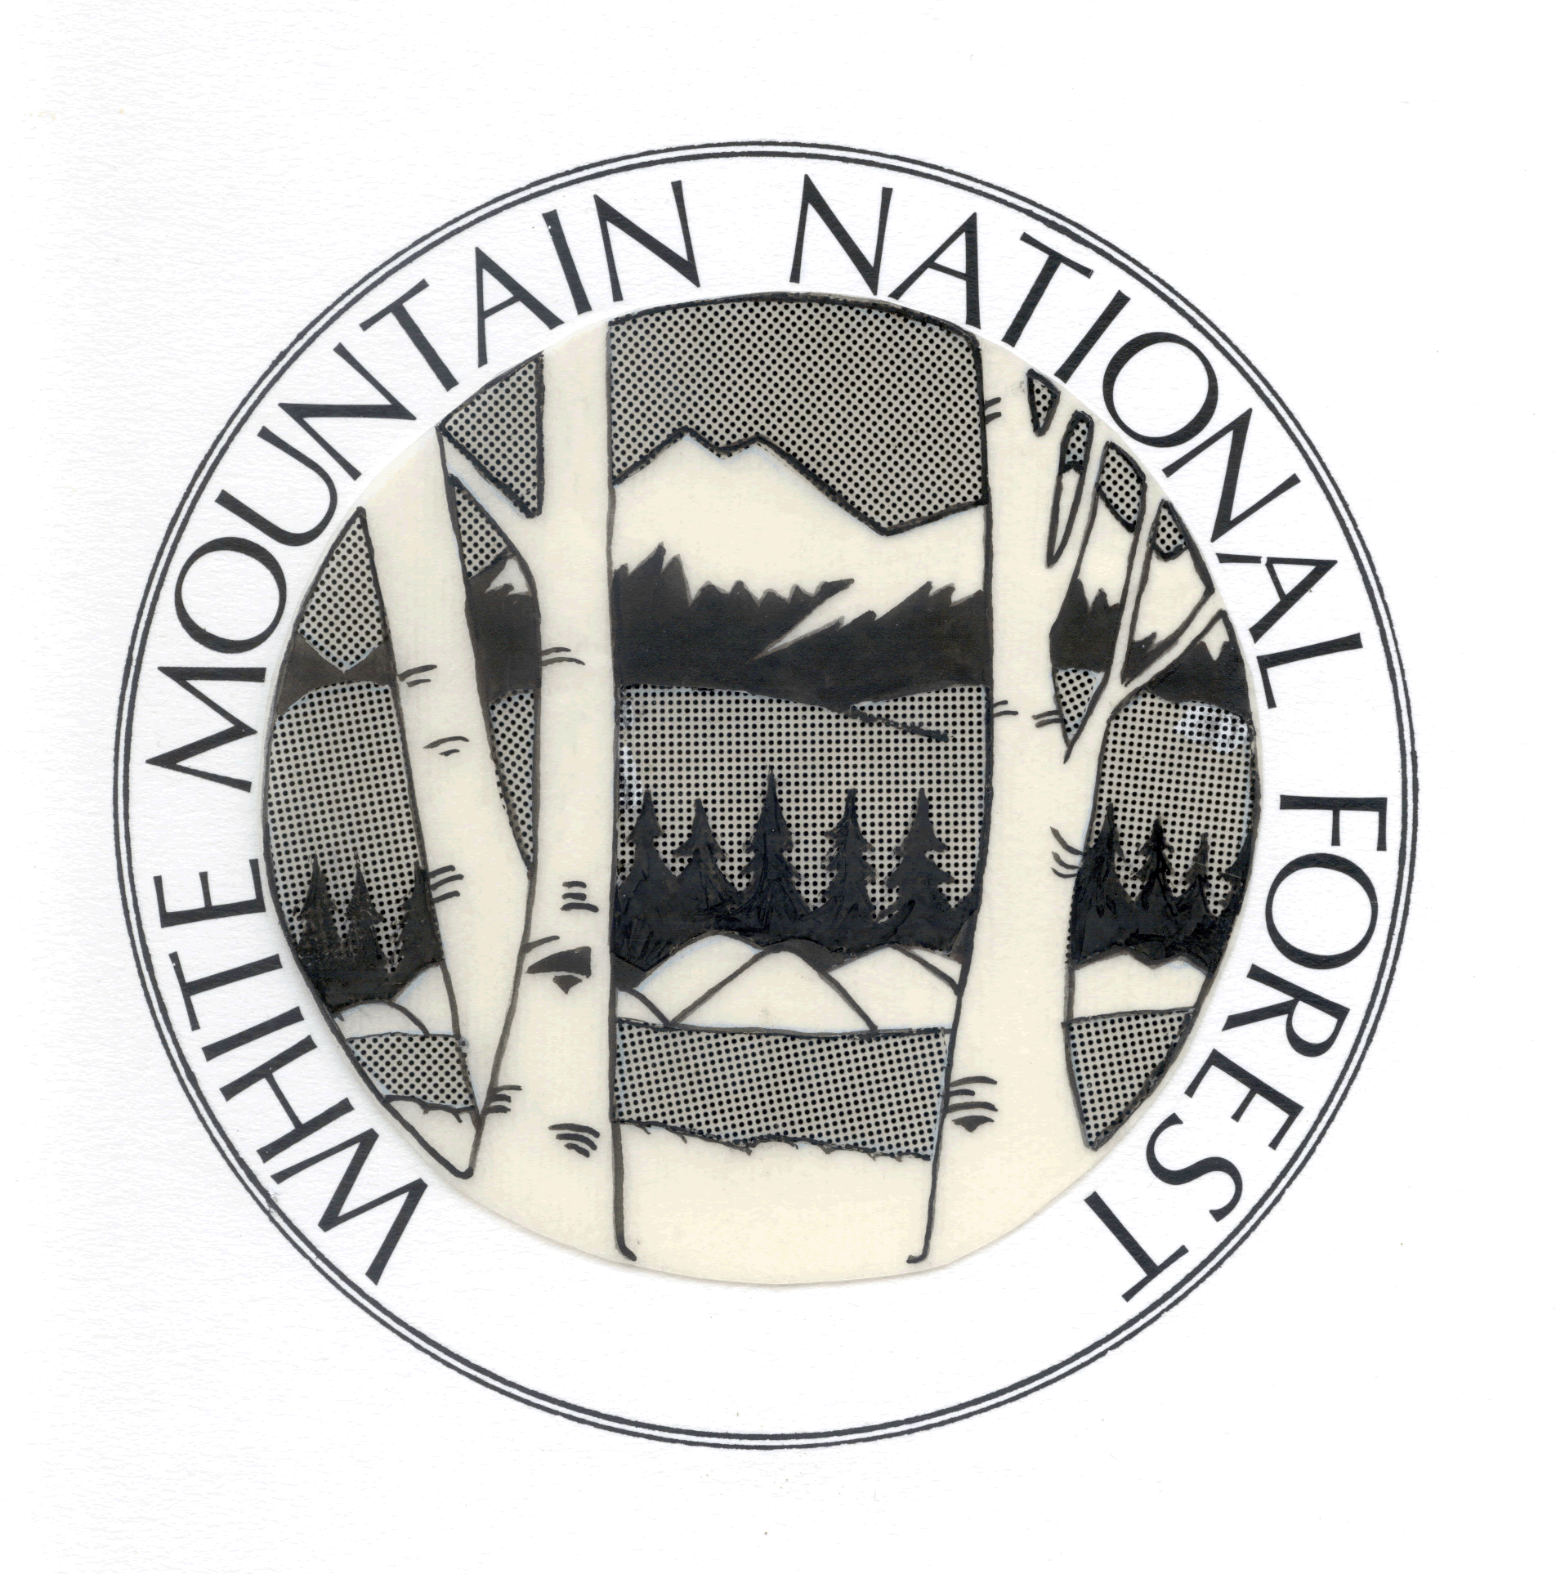
Outreach Notice
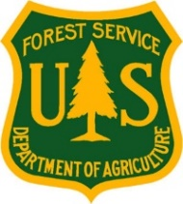
Biological Science Technician (Plants)
GS-404-07
White Mountain National Forest
Campton, New Hampshire

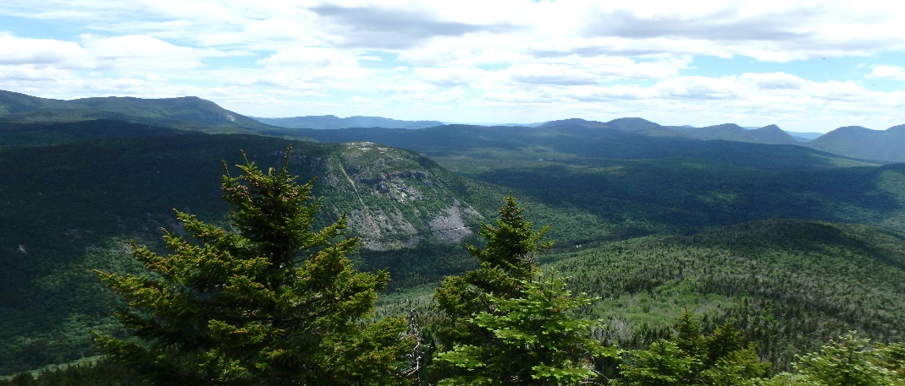

The White Mountain National Forest will soon be advertising for a Biological Science Technician (Plants). This is a permanent seasonal appointment, with 18 pay periods in pay status (approximately mid-March to mid-November) and 8 pay periods in non-pay status each year. Starting pay is approximately $20.93 per hour. The position is located at the White Mountain National Forest headquarters in Campton, New Hampshire, but work will occur throughout the entire Forest.

About The Position (FS3086)
This position is responsible for assisting the Forest Botanist, primarily with field surveys: completing floristic surveys, mostly in forest habitats; looking for rare plants and invasive species and documenting plants observed; collecting field data on field forms and digital tablets; processing this information in the office in GIS, spreadsheets, and text descriptions; providing recommendations to be incorporated into environmental analyses, and working with a variety of staff to communicate information. There will be a minor amount of non-native invasive species treatment work. The hired candidate will need to be able to work independently much of the time and be able to walk up to 10 miles per day across steep and rugged terrain. The ability to navigate by GPS, maps, and compass is essential. Other desired qualities include past experience in rare species field identification, the ability to be flexible and adapt to changing priorities, to be self-motivated under minimal supervision, and to possess an excellent work ethic and commitment to promoting a safe and inclusive work environment.

Additional information on benefits of working for the Forest Service can be found here: https://www.fs.fed.us/working-with-us/jobs/why-work-with-us

About The Forest
The White Mountain National Forest encompasses approximately 800,000 acres in northern New Hampshire (including Coos, Carroll, and Grafton Counties) and western Maine (Oxford County).

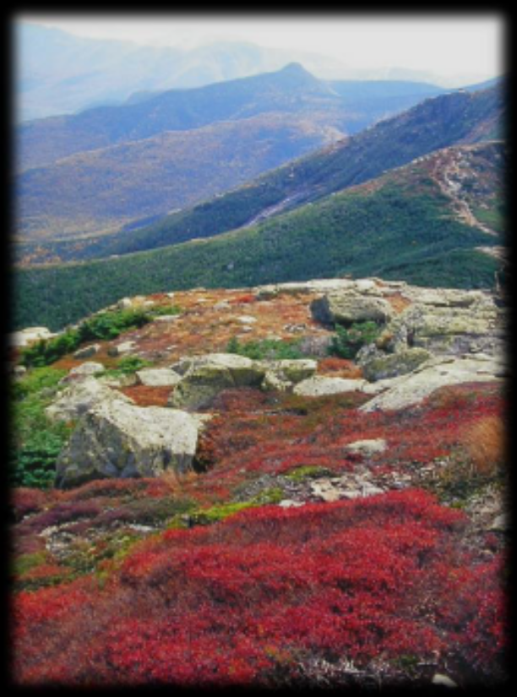
Characterized by rugged mountain peaks and the largest alpine zone in the East, the Forest has forty-eight summits of 4,000 feet and higher, including Mount Washington, the highest peak in the Northeast. This dramatic landscape, so close to major metropolitan areas (Boston, Massachusetts, is only 130 miles to the south; New York City only a half-day drive; and Montreal, Quebec, less than one day’s drive), has made the White Mountains a destination for people seeking a variety of recreation experiences for two centuries.

The landscape of the White Mountain National Forest is unique in New England. It provides opportunities that are not available on private or other public lands. The Forest’s resources are managed to ensure that their social and economic values to the region will benefit both present and future generations. An active forestry program integrates production of wood products with wildlife habitat, watershed management, soil conservation, and scenery objectives. The White Mountain Region is a four season recreation destination. Recreational opportunities are numerous, including summer activities of camping, hiking, climbing, fishing - both lakes and rivers, boating, swimming, surfing - the Atlantic Ocean is a short drive (about 2 hours), wildlife watching, tax-free shopping, picnicking, the arts and other forms of entertainment too numerous to mention. During the winter months, hunting, downhill and cross-country skiing, snowmobiling, winter mountaineering, ice climbing and other winter sports are popular.

For further information about the Forest, see our website: www.fs.usda.gov/whitemountain

Area Information
The White Mountain National Forest headquarters is located in Campton, New Hampshire. This LEED certified office was built in 2009. Campton and other neighboring rural towns (including Rumney, Thornton, Holderness, Ashland, and Waterville Valley) have populations of about 1,000 each. Nearby is the city of Plymouth which has a population of about 7,000. The economy of the area is split between recreation, education, services, and forest products. Plymouth is a full-service community and is home to Plymouth State University, Speare Memorial Hospital, and numerous clinics. All towns have public K-8 schools, with a regional high school in Plymouth. There is also a public charter school in Plymouth (grades 1-8) and nearby private elementary and high schools. There are several banks and credit unions in the area. Churches for just about every denomination are present in the region.

There is no State income or sales tax in New Hampshire, and property taxes are above average. Houses in the area rent for about $600-$1800 per month and sell for $100,000 to $400,000+. House prices rise in proximity to ski areas and the numerous lakes. Government-owned housing is not available.

How to Apply
The purpose of this Outreach Notice is to notify potential candidates and to gauge interest in the position. Anyone responding to this outreach will be notified when the job announcement is posted. To respond to this Outreach, visit the Forest Service Outreach Database (https://fsoutreach.gdcii.com/), search for this position, and submit the online response.

The job announcement for this position will be posted on USAJOBS, the U.S. Government’s official website for employment opportunities, at https://www.usajobs.gov/.
It is advisable to establish a profile and upload your resume prior to the announcement, as the period to apply may be brief.

For more information, contact Leighlan Prout, Wildlife Program Leader (leighlan.prout@usda.gov) or Dan Sperduto, Forest Botanist (daniel.d.sperduto@usda.gov).

