
Job Posting
Land Conservation Projects Manager, Maine

Who We Are:
The Nature Conservancy’s mission is to protect the lands and waters upon which all life depends. As a science-based organization, we create innovative, on-the-ground solutions to our world’s toughest challenges so that we can create a world in which people and nature thrive. We’re rooted in our Mission and guided by our Values, which includes a Commitment to Diversity and Respect for People, Communities, and Cultures. Whether it’s career development, flexible schedules, or a rewarding mission, there’s lots of reasons to love life #insideTNC. Want a better insight to TNC? Check out our TNC Talent playlist on YouTube or on Glassdoor.
Our goal is to cultivate an inclusive work environment so that all our colleagues around the globe feel a sense of belonging, and that their unique contributions to our mission are valued. We know we’ll only achieve our Mission by hiring and engaging a diverse workforce that reflects the communities in which we work. In addition to the requirements in our postings, we recognize that people come with talent and experiences outside of a job. Diversity of experience and skills combined with passion is a key to innovation and a culture of inclusion! Please apply – we’d love to hear from you. To quote myriad TNC staff members, “you’ll join for our mission, and you’ll stay for our people.”

What We Can Achieve Together:
The Forest Conservation Project Manager accomplishes conservation outcomes in Maine’s resilient and connected forests that are essential to people and nature, including oversight and management of real estate transactions, grants, and contracts, while working closely with The Nature Conservancy colleagues and partners.
RESPONSIBILITIES & SCOPE
- Collaborate with and support Conservation, Finance, Government Relations, Land Management, Legal, Philanthropy, and Communications colleagues on conservation projects that advance The Nature Conservancy’s priorities.
- Provide real estate and project management assistance toward the achievement of program goals. Manage all aspects of real estate transactions: participate in evaluation of potential projects; communicate with property owners; conduct property inspections; track and record project progress; contract for due diligence; prepare and present project summaries and updates; support budgeting and financial oversight for land projects and assist in writing public funding proposals.
- Participate in and contribute to partnerships with local, state, federal, and tribal governments, and other partners; may assist with transfers of TNC properties to partners.
- May partner with Philanthropy staff to fundraise for projects including helping to cultivate potential corporate, foundation, and individual donors.
- May work in variable weather conditions, at remote locations, on difficult and hazardous terrain and under physically demanding circumstances.

We’re Looking for You:

Want to help save the planet? Through the efforts of The Nature Conservancy, over 2,400,000 acres in Maine have been preserved for people and nature. The Maine Chapter is The Nature Conservancy's fourth oldest chapter, founded in 1956 by Rachel Carson and other leading Maine citizens concerned about the loss of wildlife habitat. TNC currently owns and manages some 300,000 acres in Maine, including the largest system of nature preserves in the state. From the mountains to the sea, the Maine Chapter is dedicated to conserving the natural resources that make Maine unique. This is an exceptional career opportunity for a highly motivated, capable individual interested in joining the world’s leading conservation organization!

What You’ll Bring:
- BA/BS, law, or business degree and 5years’ experience in natural resource management or related field or equivalent combination of education and experience.
- Project management experience.
- Demonstrated capability for completing tasks independently and with respect to timeline(s).
- Excellent communication skills via written, spoken, and graphical means in English and other relevant languages. Ability to explain conservation practices to technical and non-technical audiences.
- Experience and proficiency using applications such as Microsoft Word, Excel, Zoom, and Web Browsers.

DESIRED QUALIFICATIONS
- Multi-lingual skills and multi-cultural or cross-cultural experience appreciated.
- Experience in partnerships with Wabanaki or other Indigenous Peoples.
- Knowledge of land management conservation practice and conservation science.
- Knowledge of current trends and practices in conservation, land management, and natural resource preservation.
- Experience communicating with the public and/or media both in writing and verbally.
- Experience using Geographic Information Systems appreciated.
- Experience negotiating complex agreements.

What We Bring:
Since 1951, The Nature Conservancy has been doing work you can believe in protecting the lands and waters that all life depends on. Through grassroots action, TNC has grown to become one of the most effective and wide-reaching environmental organizations in the world. Thanks to more than 1 million members, over 400 scientists, and the dedicated efforts of our diverse staff, we impact conservation throughout the world!

The Nature Conservancy offers a competitive, comprehensive benefits package including: health care benefits, flexible spending accounts, 401(k) plan including employer match, parental leave, accrued paid time off, life insurance, disability coverage, employee assistance program, other life and work wellbeing benefits. Learn more about our benefits at in the Culture Tab on nature.org/careers.

We’re proud to offer a work-environment that is supportive of the health, wellbeing, and flexibility needs of the people we employ!

This description is not designed to be a complete list of all duties and responsibilities required for this job.

Our Competencies:
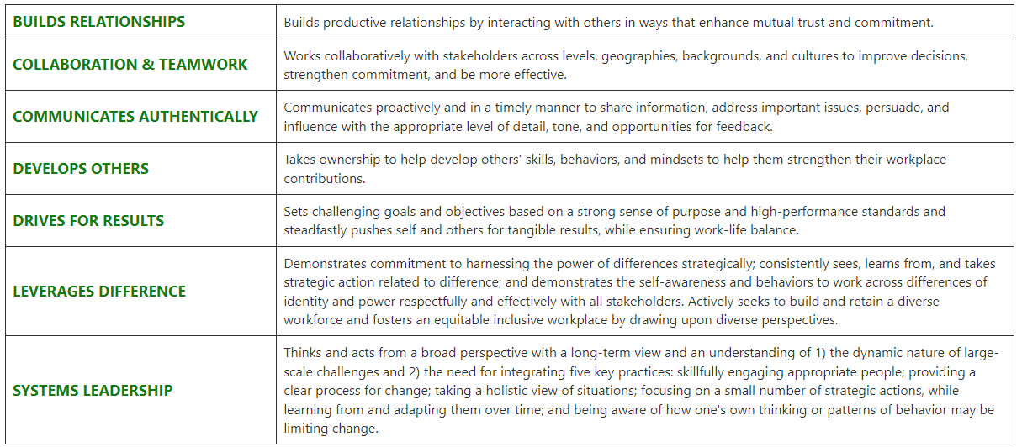

The Nature Conservancy is an Equal Opportunity Employer. Our commitment to diversity includes the recognition that our conservation mission is best advanced by the leadership and contributions of people of diverse backgrounds, beliefs, and cultures. Recruiting and mentoring staff to create an inclusive organization that reflects our global character is a priority and we encourage applicants from all cultures, races, colors, religions, sexes, national or regional origins, ages, disability status, sexual orientations, gender identities, military, protected veteran status or other status protected by law.
TNC is committed to offering accommodations for qualified individuals with disabilities and disabled veterans in our job application process. If you need assistance or an accommodation due to a disability, please send a note to applyhelp@tnc.org with Request for Accommodation in the subject line.

For Internal Reporting:
Job Title: Conservation Practitioner V
Job Family: Conservation
Internal Job Code: 450005
Salary Grade: 6
Status: Salaried
PeopleSoft Job ID Number:
Date: October 2022

