
Job Posting
Director of Conservation Science in Maine

Who We Are:
The Nature Conservancy’s mission is to protect the lands and waters upon which all life depends. As a science-based organization, we create innovative, on-the-ground solutions to our world’s toughest challenges so that we can create a world in which people and nature thrive. We’re rooted in our Mission and guided by our Values, which includes a Commitment to Diversity and Respect for People, Communities, and Cultures. Whether it’s career development, flexible schedules, or a rewarding mission, there’s lots of reasons to love life #insideTNC. Want a better insight to TNC? Check out our TNC Talent playlist on YouTube or on Glassdoor.
Our goal is to cultivate an inclusive work environment so that all our colleagues around the globe feel a sense of belonging, and that their unique contributions to our mission are valued. We know we’ll only achieve our Mission by hiring and engaging a diverse workforce that reflects the communities in which we work. In addition to the requirements in our postings, we recognize that people come with talent and experiences outside of a job. Diversity of experience and skills combined with passion is a key to innovation and a culture of inclusion! Please apply – we’d love to hear from you. To quote myriad TNC staff members, “you’ll join for our mission, and you’ll stay for our people.”
What We Can Achieve Together:
The Director of Conservation Science and Planning plays a critical role inspiring and guiding the strategies and actions of TNC’s Maine Business Unit (BU). To accomplish this, they convene, facilitate and synthesize information from a diverse range of disciplines and sources, develop and leverage collaborative relationships with partners including those from local communities, academia, state and federal agencies, Tribal governments, and other non-profits, and supervise a small team of talented staff to build on and expand how all forms of knowledge are applied to conservation. Working closely with cross-functional teams, they deploy strategic thinking and a collaborative, inclusive approach to guide the Maine BU’s applied conservation programs including forests, freshwater, oceans, climate adaptation and climate action/energy siting. They report to the Associate State Director in Maine and interface regularly with regional, national and global colleagues to ensure lessons are shared and best practices applied to achieving positive outcomes for nature and people. May work in variable weather conditions, at remote locations, in hazardous terrain and under physically demanding circumstances.

We’re Looking for You:
Are you looking for a career where you can make a lasting difference for Maine and the planet? Guided by science, The Nature Conservancy creates innovative, on-the-ground solutions to our world’s toughest challenges so that people and nature can thrive together. If you are a passionate, dynamic and creative leader – we’d love to hear from you! The ideal candidate will have excellent networking, communication, collaboration and synthesis skills and experience designing and supporting complex conservation projects. This is an exciting opportunity to work across multiple teams and disciplines to contribute to TNC’s mission, in Maine and beyond. Apply today and join TNC in Maine!

What You’ll Bring:
- Master's Degree in conservation science related field and 2 years of experience or equivalent combination of education and experience. Experience managing staff, project, workloads and finances under deadlines.
- Interdisciplinary experience working across natural and social systems.
- Experience synthesizing, interpreting, and communicating scientific information.
- Experience preparing reports of findings.
- Experience working and communicating with a wide range of people.

DESIRED QUALIFICATIONS
- Proven, enthusiastic collaborator across functions and programs, able to engage in a wide range of conservation issues, analyze complex problems, rapidly build personal/team expertise, and develop strategic responses or solutions.
- Demonstrated ability to effectively network and develop relationships with a wide range of individuals, including staff, academic institutions, government agencies, and other stakeholders.
- Dynamic and engaging communication skills with experience translating and conveying complex scientific issues to a broad range of audiences, including donors, media and the general public.
- Strong interpersonal skills with inclusive, open-minded approach that elevates voices of others.
- Proven ability to connect and leverage applied scientific concepts, multiple ways of knowing, and technical innovations for broader impact.
- Fundraising experience including writing proposals and interacting with public & private donors.
- Record of peer reviewed publications in scientific journals.
- Multi-language skills and multi-cultural or cross-cultural experience appreciated.
- Proven negotiation skills.

What We Bring:
Since 1951, The Nature Conservancy has been doing work you can believe in protecting the lands and waters that all life depends on. Through grassroots action, TNC has grown to become one of the most effective and wide-reaching environmental organizations in the world. Thanks to more than 1 million members, over 400 scientists, and the dedicated efforts of our diverse staff, we impact conservation throughout the world!

The Nature Conservancy offers a competitive, comprehensive benefits package including: health care benefits, flexible spending accounts, 401(k) plan including employer match, parental leave, accrued paid time off, life insurance, disability coverage, employee assistance program, other life and work wellbeing benefits. Learn more about our benefits at in the Culture Tab on nature.org/careers.

We’re proud to offer a work-environment that is supportive of the health, wellbeing, and flexibility needs of the people we employ!

This description is not designed to be a complete list of all duties and responsibilities required for this job.

Our Competencies:
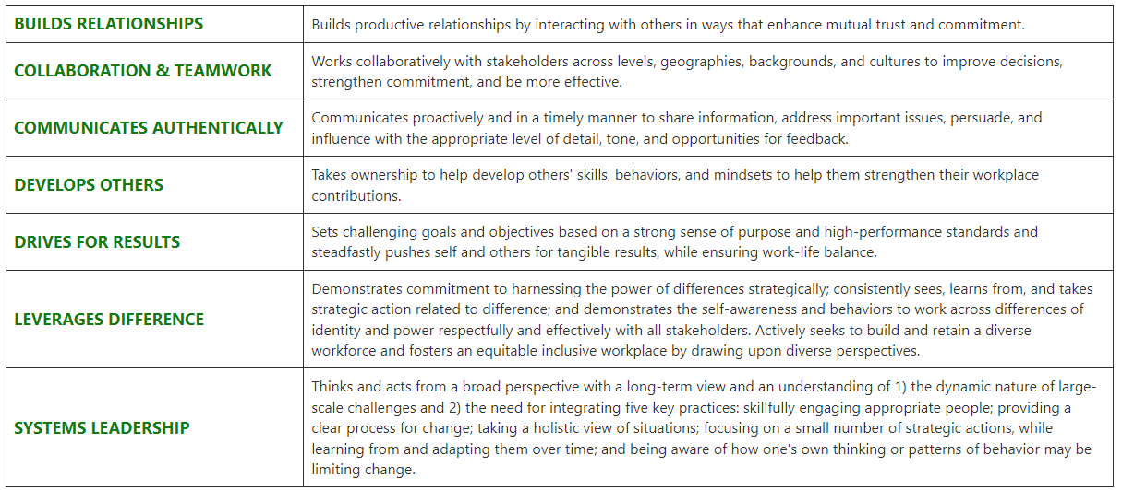

The Nature Conservancy is an Equal Opportunity Employer. Our commitment to diversity includes the recognition that our conservation mission is best advanced by the leadership and contributions of people of diverse backgrounds, beliefs, and cultures. Recruiting and mentoring staff to create an inclusive organization that reflects our global character is a priority and we encourage applicants from all cultures, races, colors, religions, sexes, national or regional origins, ages, disability status, sexual orientations, gender identities, military, protected veteran status or other status protected by law.
TNC is committed to offering accommodations for qualified individuals with disabilities and disabled veterans in our job application process. If you need assistance or an accommodation due to a disability, please send a note to applyhelp@tnc.org with Request for Accommodation in the subject line

For Internal Reporting:
Job Title: Applied Scientist II
Job Family: Science
Internal Job Code: 400002
Salary Grade: 7
Status: Salaried
PeopleSoft Job ID Number:
Date: May 2022

