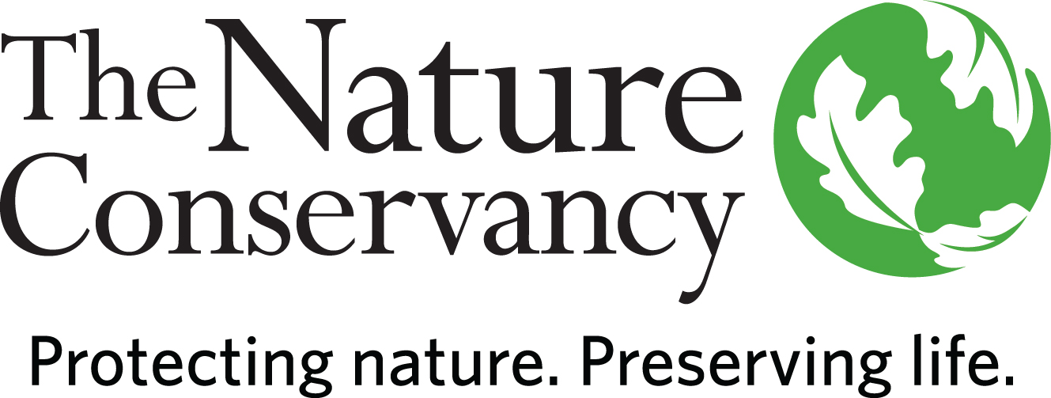

POSITION DESCRIPTION

Land Protection Manager

Location: Massachusetts

Status: Full-time (35 hours/week)

Who We Are:
The Nature Conservancy’s mission is to protect the lands and waters upon which all life depends. As a science-based organization, we create innovative, on-the-ground solutions to our world’s toughest challenges so that we can create a world in which people and nature thrive. We’re rooted in our Mission and guided by our Values, which includes a Commitment to Diversity and Respect for People, Communities, and Cultures. Whether it’s career development, flexible schedules, or a rewarding mission, there’s lots of reasons to love life #insideTNC. Want a better insight to TNC? Check out our TNC Talent playlist on YouTube or on Glassdoor.
Our goal is to cultivate an inclusive work environment so that all our colleagues around the globe feel a sense of belonging, and that their unique contributions to our mission are valued. We know we’ll only achieve our Mission by hiring and engaging a diverse workforce that reflects the communities in which we work. In addition to the requirements in our postings, we recognize that people come with talent and experiences outside of a job. Diversity of experience and skills combined with passion is a key to innovation and a culture of inclusion! Please apply – we’d love to hear from you. To quote myriad TNC staff members, “you’ll join for our mission, and you’ll stay for our people.”
The Massachusetts Chapter believes in flexibility and as such, team members are working in a hybrid model. This position is full time and has the option of working remotely or from one of our TNC offices in Massachusetts: Boston or Sheffield, with the expectation of in-person workdays and meetings on a regular basis. By joining our Massachusetts team, you will become part of a group that is a force to be reckoned with, a force for nature, a force for people, and a force for our planet. Our team consists of a dedicated group who are leading the conservation effort on multiple fronts and who expertly bring strategy and action together.

The starting pay range for a candidate selected for this position is generally within the range of $68,000-$83,000 for annual base salary. This range only applies to candidates whose country of employment is the USA. Where a successful candidate’s actual pay will fall within this range will be based on a variety of factors, including, for example, the candidate's location, qualifications, specific skills, and experience. Please note countries outside the USA would have a different pay range in the local currency based on the local labor market, and not tied to USA pay or ranges. Your geographic location will be confirmed during the recruitment.

What We Can Achieve Together:
The Land Protection Manager leads key strategies towards making TNC in MA’s greatest contribution to the organization’s 2030 goals of tackling climate change and conserving healthy lands and waters. The role serves as the Chapter’s land protection expert and collaborates with conservation staff. They represent the Conservancy on multi-disciplinary/multi-partner project teams and collaborates and builds partnerships with federal and state agencies, towns, regional and local land trusts, as well as private landowners. They work on regional projects and with programs throughout the Conservancy. They employ a full range of protection tools to acquire and/or convey varying degrees of legal interest in land and implements a variety of strategies to secure public and private support for TNC initiatives for freshwater, coastal and terrestrial habitat protection and management, as well as climate mitigation and adaptation. They provide technical and project management expertise in complying with legal requirements and internal policies for TNC real estate interests (including fee-owned properties, conservation easements, and partner Assists). The Land Protection Manager works closely with TNC legal and stewardship staff and other colleagues at many levels in multiple functions and departments to coordinate resolutions of legal issues on fee-owned lands and easement violations. They maintain positive relationships with local donors, supporters, community groups and partner agencies. They will advance equity in conservation in relationships and projects.

We’re Looking for You:
Are you looking for work you can believe in? At TNC we strive to embody a philosophy of Work that You Can Believe in where you can feel like you are making a difference every day. We’re looking for someone with strong experience in being a part of a diverse, multi-disciplinary team.

This is an exciting opportunity to contribute to the ongoing mission of conservation by working in a strategic role that works closely with colleagues and partners to create lasting change. Specific responsibilities include:

- Build strategy, manage and implement key land protection strategies for greatest impact to TNC in MA’s 2030 protected land and freshwater acre goals in collaboration with MA Director of Rivers & Lands, MA Chapter staff, and cross state TNC staff on regional initiatives.
- Manage all aspects of real estate transactions: screen potential projects; communicate with property owners; conduct property inspections; negotiate, track and record project progress; contract for due diligence; prepare and present project packages and updates to project committee; collaborate with TNC Legal, Finance, Development, and Stewardship Programs, and obtain TNC corporate project approvals.
- Collaborate with local, state and federal government and partners on various conservation projects that advance and leverage TNC priorities.
- Provide real estate and project management assistance to conservation program staff working toward the achievement of program goals.
- Assist relevant communities to implement land acquisition as a Nature Based Solution, through planning and technical assistance, to help address climate resilience and emergency management planning.
- Financial responsibility may include working within/managing a budget to complete projects, negotiating and contracting with vendors, assisting with budget development, and meeting fundraising targets. .
- Partner with Development staff to fundraise for projects: cultivate corporate, foundation and individual prospects, and solicit public funding for projects through grants.
- May manage interns or staff, with responsibility for performance management, training and career development.
- Ensures program compliance with internal policies and external requirements.
- Under minimal supervision, makes independent decisions based on analysis, experience and context.
- May work in variable weather conditions, at remote locations, on difficult and hazardous terrain and under physically demanding circumstances.

What You’ll Bring:
- BA/BS, law or business degree and 5 years’ experience in natural resource management or related field or equivalent combination of education and experience.
- Experience with real estate and land acquisition and ability to structure and negotiate complex deals and agreements.
- Experience building relationships and communicating with a variety of internal and external stakeholders.
- Project management experience.
- Experience staying organized and driven while working independently.
- Experience using common software applications such as Word, Excel, web browsers, etc.
- Must have valid driver's license and ability to travel regularly within Massachusetts and regionally, as needed.
- Comfort working in variable weather conditions and at remote locations as necessary.

What We Bring:
Since 1951, The Nature Conservancy has been doing work you can believe in protecting the lands and waters that all life depends on. Through grassroots action, TNC has grown to become one of the most effective and wide-reaching environmental organizations in the world. Thanks to more than 1 million members, over 400 scientists, and the dedicated efforts of our diverse staff, we impact conservation throughout the world!

The Nature Conservancy offers a competitive, comprehensive benefits package including health care benefits, flexible spending accounts, 401(k) plan including employer match, parental leave, accrued paid time off, life insurance, disability coverage, employee assistance program, other life and work wellbeing benefits. Learn more about our benefits at in the Culture Tab on nature.org/careers.

We’re proud to offer a work-environment that is supportive of the health, wellbeing, and flexibility needs of the people we employ!

This description is not designed to be a complete list of all duties and responsibilities required for this job.

Our Competencies:
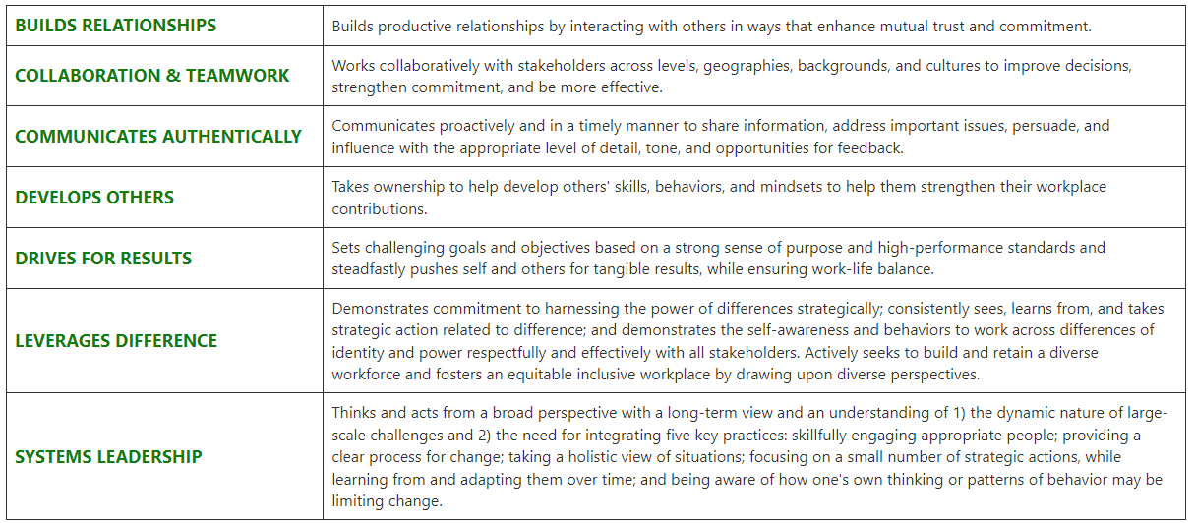

The Nature Conservancy is an Equal Opportunity Employer. Our commitment to diversity includes the recognition that our conservation mission is best advanced by the leadership and contributions of people of diverse backgrounds, beliefs, and cultures. Recruiting and mentoring staff to create an inclusive organization that reflects our global character is a priority and we encourage applicants from all cultures, races, colors, religions, sexes, national or regional origins, ages, disability status, sexual orientations, gender identities, military, protected veteran status or other status protected by law.
TNC is committed to offering accommodations for qualified individuals with disabilities and disabled veterans in our job application process. If you need assistance or an accommodation due to a disability, please send a note to applyhelp@tnc.org with Request for Accommodation in the subject line.

For Internal Reporting:
Salary: Grade 6/Exempt
Job Title: Conservation Practitioner VI
Job Family: Conservation
Internal Job Code: 450005

TO APPLY:
Please visit www.nature/org/careers and search for job #54190.
Please upload a resume and cover letter.

