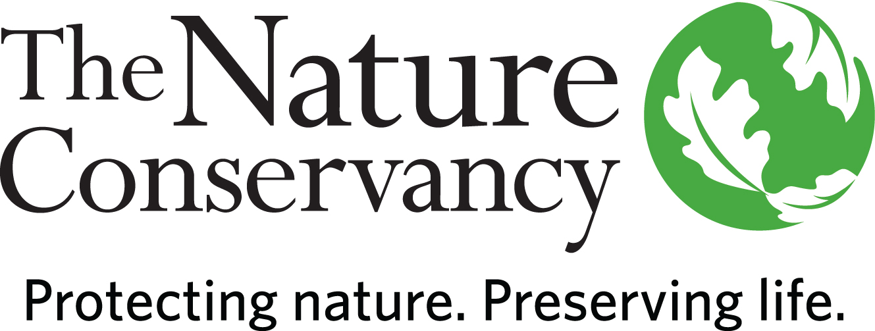

POSITION DESCRIPTION

Stewardship Coordinator

Location: Western Massachusetts

Status: Full-time (35 hours/week), At least 2 days required in the Sheffield, MA office

Who We Are:
The Nature Conservancy’s mission is to protect the lands and waters upon which all life depends. As a science-based organization, we create innovative, on-the-ground solutions to our world’s toughest challenges so that we can create a world in which people and nature thrive. We’re rooted in our Mission and guided by our Values, which includes a Commitment to Diversity and Respect for People, Communities, and Cultures. Whether it’s career development, flexible schedules, or a rewarding mission, there’s lots of reasons to love life #insideTNC. Want a better insight to TNC? Check out our TNC Talent playlist on YouTube or on Glassdoor.
Our goal is to cultivate an inclusive work environment so that all our colleagues around the globe feel a sense of belonging, and that their unique contributions to our mission are valued. We know we’ll only achieve our Mission by hiring and engaging a diverse workforce that reflects the communities in which we work. In addition to the requirements in our postings, we recognize that people come with talent and experiences outside of a job. Diversity of experience and skills combined with passion is a key to innovation and a culture of inclusion! Please apply – we’d love to hear from you. To quote myriad TNC staff members, “you’ll join for our mission, and you’ll stay for our people.”
The Massachusetts Chapter believes in flexibility and as such, team members are working in a hybrid model.
This position is based in Western Massachusetts with an expectation of commuting proximity to our Sheffield office. Due to the office management responsibilities of this role, we expect the Stewardship Coordinator to work in the office at least 2 days/week. By joining our Massachusetts team, you will become part of a group that is a force to be reckoned with, a force for nature, a force for people, and a force for our planet. Our team consists of a dedicated group who are leading the conservation effort on multiple fronts and who expertly bring strategy and action together.

The starting pay range for a candidate selected for this position is generally within the range of $47,000- $56,000 for annual base salary. This range only applies to candidates whose country of employment is the USA. Where a successful candidate’s actual pay will fall within this range will be based on a variety of factors, including, for example, the candidate's location, qualifications, specific skills, and experience. Please note countries outside the USA would have a different pay range in the local currency based on the local labor market, and not tied to USA pay or ranges. Your geographic location will be confirmed during the recruitment.

What We Can Achieve Together:
The Stewardship Coordinator, based out of the Sheffield office, will assist in advancing stewardship program functions as well as field activities on Conservancy preserves within Massachusetts. Administrative duties include office management and support for the Massachusetts Chapter stewardship team which includes tracking legal compliance monitoring, updating management plans, and maintaining program records and files, including GIS maps and data. Fieldwork duties will include legal compliance monitoring, ecological monitoring, invasive species control, wildlife research, using and maintaining equipment, safely applying herbicide, enforcing preserve policies and monitoring visitor use, performing trail, boundary, and sign maintenance, and maintaining cooperative relationships.

We’re Looking for You:
Are you looking for work you can believe in? At TNC we strive to embody a philosophy of Work that You Can Believe in where you can feel like you are making a difference every day. We’re looking for someone with strong experience in being a part of a diverse, multi-disciplinary team.

This is an exciting opportunity to contribute to the ongoing mission of conservation by working in a integral role on both side of conservation: behind the scenes (70%) and in the field (30%) - a key, hands-on role! Specific responsibilities include:

Stewardship Program Support
- Assist with administration of the MA Stewardship Program including legal compliance monitoring, updating management plans, maintaining program records and files, supporting stewardship team volunteer administration, and other tasks, as needed.
- Support GIS for stewardship and other conservation staff. This includes map creation and data collection for a statewide mobile monitoring system, TNC lands GIS data, creation of land project and grant application maps. It also includes coordinating deployment of several tablets, as well as providing technical support to stewardship staff for a suite of ESRI mobile apps (e.g. Fieldmaps, Quickcapture, Survey123, ArcGIS Online).
- Partner with Business Unit Records Coordinator to ensure stewardship and other related records are tracked and stored in compliance with TNC policies and Standard Operating Procedures.

Office Management
- Manage the Sheffield Office to keep it functional and efficient. Function as the main liaison with the landlord for maintenance and repairs. Act as main point of contact for office equipment contracts and troubleshooting by partnering closely with IT and operations staff. Purchase office equipment and supplies and work with the operations team to ensure all office safety/emergency plans, including documentation and training when appropriate.
- Assist the Director of Operations with managing and coordinating tenants.

Fieldwork
- Conduct annual legal compliance monitoring of preserves and conservation easements, enter monitoring data. Work collaboratively with legal and stewardship teams to address problems as they arise on preserves (may include trespass, unauthorized vehicular use etc) and conservation easements.
- Perform preserve maintenance tasks (maintain signs, maintain trails, mark boundaries, control invasive species (using hand tools and herbicides), either independently or with other staff.
- Interact with preserve visitors by providing information about the preserves, promoting the work of the Conservancy, answering questions, and enforcing preserve policies.
- Assist with organization and maintenance of stewardship equipment such as hand and power tools, chainsaws, brush saws, and coordinate maintenance for the work truck.
- Occasionally lead and supervise volunteers and/or interns assisting with preserve maintenance activities.
- Assist with other stewardship and science projects as needed.

What You’ll Bring:
- Bachelor’s degree in biology, ecology, natural resources management or related field and 2 years related work experience or equivalent combination of education and experience.
- Experience coordinating administrative processes and projects.
- Experience with ecological principles and plant identification.
- Experience with mobile technology (tablets or smartphones), proficiency with ESRI ArcPro and ArcGIS Online, and creating, managing and interpreting mapped information.
- Experience operating and or repairing various types of equipment and machinery.
- Requires ability to complete physical work in variable weather conditions, at remote locations, on difficult and hazardous terrain, and under physically demanding circumstances.
- Requires valid driver’s license.
Requires either a current MA Pesticide Applicator License (Core) or willingness to take the exam required to obtain a Core license.

What We Bring:
Since 1951, The Nature Conservancy has been doing work you can believe in protecting the lands and waters that all life depends on. Through grassroots action, TNC has grown to become one of the most effective and wide-reaching environmental organizations in the world. Thanks to more than 1 million members, over 400 scientists, and the dedicated efforts of our diverse staff, we impact conservation throughout the world!

The Nature Conservancy offers a competitive, comprehensive benefits package including health care benefits, flexible spending accounts, 401(k) plan including employer match, parental leave, accrued paid time off, life insurance, disability coverage, employee assistance program, other life and work wellbeing benefits. Learn more about our benefits at in the Culture Tab on nature.org/careers.

We’re proud to offer a work-environment that is supportive of the health, wellbeing, and flexibility needs of the people we employ!

This description is not designed to be a complete list of all duties and responsibilities required for this job.

Our Competencies:
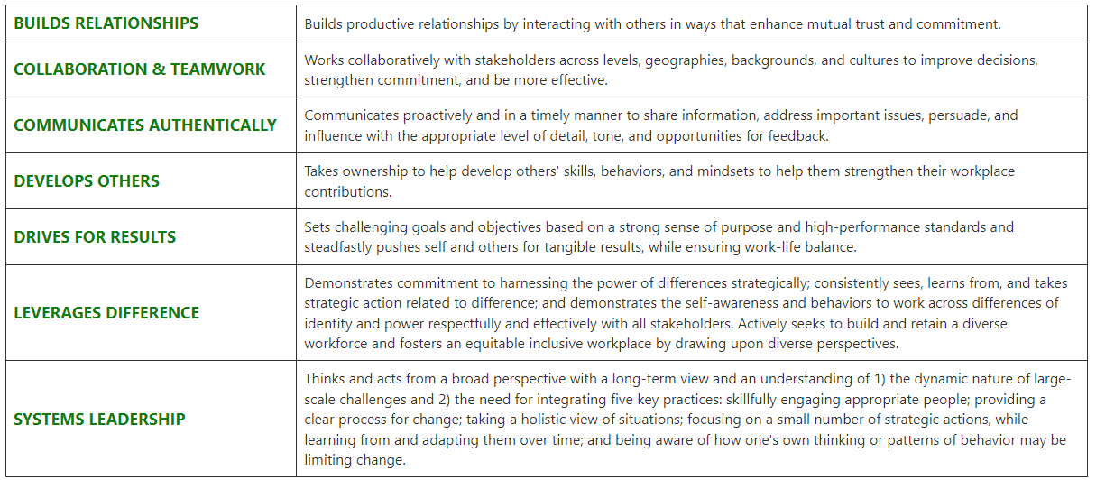

The Nature Conservancy is an Equal Opportunity Employer. Our commitment to diversity includes the recognition that our conservation mission is best advanced by the leadership and contributions of people of diverse backgrounds, beliefs, and cultures. Recruiting and mentoring staff to create an inclusive organization that reflects our global character is a priority and we encourage applicants from all cultures, races, colors, religions, sexes, national or regional origins, ages, disability status, sexual orientations, gender identities, military, protected veteran status or other status protected by law.
TNC is committed to offering accommodations for qualified individuals with disabilities and disabled veterans in our job application process. If you need assistance or an accommodation due to a disability, please send a note to applyhelp@tnc.org with Request for Accommodation in the subject line.

For Internal Reporting:
Salary: Grade 4/Non-Exempt
Job Title: Conservation Coordinator
Job Family: Conservation
Internal Job Code: 570002

TO APPLY:
Please visit www.nature/org/careers and search for job #54131.
Please upload a resume and cover letter.

