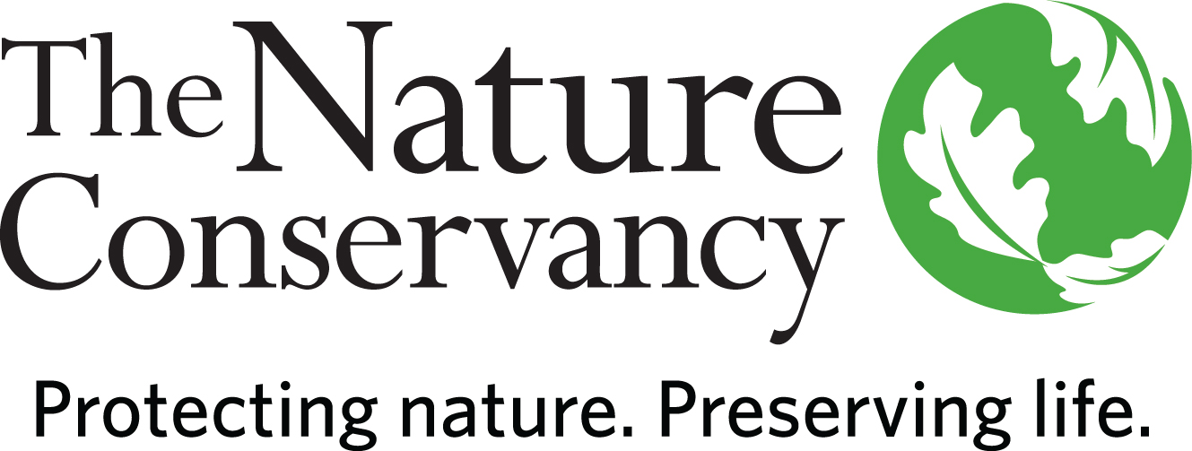

POSITION DESCRIPTION

Stewardship Manager, Islands & Southeastern Massachusetts

Location: Martha’s Vineyard or Southeastern Massachusetts (with regular travel to MV)

Status: Full-time (35 hours/week)

Who We Are:
The Nature Conservancy’s mission is to protect the lands and waters upon which all life depends. As a science-based organization, we create innovative, on-the-ground solutions to our world’s toughest challenges so that we can create a world in which people and nature thrive. We’re rooted in our Mission and guided by our Values, which includes a Commitment to Diversity and Respect for People, Communities, and Cultures. Whether it’s career development, flexible schedules, or a rewarding mission, there’s lots of reasons to love life #insideTNC. Want a better insight to TNC? Check out our TNC Talent playlist on YouTube or on Glassdoor.
Our goal is to cultivate an inclusive work environment so that all our colleagues around the globe feel a sense of belonging, and that their unique contributions to our mission are valued. We know we’ll only achieve our Mission by hiring and engaging a diverse workforce that reflects the communities in which we work. In addition to the requirements in our postings, we recognize that people come with talent and experiences outside of a job. Diversity of experience and skills combined with passion is a key to innovation and a culture of inclusion! Please apply – we’d love to hear from you. To quote myriad TNC staff members, “you’ll join for our mission, and you’ll stay for our people.”
The Massachusetts Chapter believes in flexibility and as such, team members are working in a hybrid model.
This position is considered remote and may be based on Martha’s Vineyard or in Southeastern Massachusetts with an expectation of regular travel to field sites on Martha’s Vineyard (60%), Southeastern MA/Cape Cod/Tuckernuck Island/Other sites (20%). The remaining 20% of work is considered programmatic/administrative. Stewardship vehicles and equipment are housed on Martha’s Vineyard and there is temporary, or permanent, lodging available on the island.

The starting pay range for a candidate selected for this position is generally within the range of $60,000 - $68,000 for annual base salary. This range only applies to candidates whose country of employment is the USA. Where a successful candidate’s actual pay will fall within this range will be based on a variety of factors, including, for example, the candidate's location, qualifications, specific skills, and experience. Please note countries outside the USA would have a different pay range in the local currency based on the local labor market, and not tied to USA pay or ranges. Your geographic location will be confirmed during the recruitment.

What We Can Achieve Together:
The Stewardship Manager, Southeastern MA & Islands will coordinate and manage stewardship and restoration activities on TNC-owned land that contributes towards improved management of TNC preserves supporting TNC’s 2030 goals. Responsibilities include all aspects of managing TNC lands including legal monitoring of fee lands and conservation easements, planning, monitoring, budgeting, project implementation, and community outreach. This position also oversees all aspects of habitat management and restoration projects including planning, permitting, contract oversight, research, and reporting. The Stewardship Manager may supervise field crews, interns and/or seasonal employees and volunteers. This position may also assist with other conservation priorities in MA, as time and need allows.

We’re Looking for You:
Are you looking for work you can believe in? At TNC we strive to embody a philosophy of Work that You Can Believe in where you can feel like you are making a difference every day. We’re looking for someone with strong experience in being a part of a diverse, multi-disciplinary team.

The ideal candidate should have experience with land stewardship and ecological restoration and the ability to drive oneself independently. This is an exciting opportunity to contribute to the ongoing mission of conservation by working in a key, hands-on role! Specific responsibilities include:

- Stewardship: Responsible for managing all TNC preserves in southeastern Massachusetts, Islands and Cape Cod. Develop long-term strategies for management, ensure compliance with TNC standard operating procedures, develop annual plans and budgets, create new tools and protocols to improve efficiency, update and implement preserve management plans by completing on the ground management activities (including equipment management, signage, boundary posting, and trail maintenance), and respond to requests for use of TNC lands.
- Legal Monitoring: Monitor conservation easements and fee-owned lands and lead efforts to resolve any encroachment or easement violations within Islands and Cape Cod properties.
- Operations: Partner with operations staff on fleet management, budgeting, and facilities management. Assist with stewardship team administration.
- Habitat Management and Restoration: Oversee habitat management and restoration work including, plan development, permitting, grant fundraising, project management and implementation, monitoring and reporting. Assist with preparatory work and attend prescribed burns. Prepare contracts and ensure that these contracts are completed in a timely manner and according to TNC standard operating procedures.
- Supervision: Supervise volunteers, interns, and seasonal staff to complete annual stewardship activities as needed. Actively recruit volunteers if necessary.
- Strategic Partnerships: Connect with Indigenous Peoples and regional and local conservation partners to address common issues, collaborate on projects, and communicate current TNC 2030 goals and conservation priorities including landscape scale restoration and management. Interpret TNC’s restoration and stewardship work to staff, donors, partners, and the general public.
- Chapter engagement: Understand the goals and work of the larger stewardship team, the MA chapter and participate as appropriate in staff and planning meetings. Support other MA Stewardship and Conservation projects as needed. Support Development staff to cultivate donor relationships, attend donor events. Support Marketing and Communications staff by providing content and acting as a TNC spokesperson, when necessary.
- Assist the Director of Stewardship & Restoration and other members of the stewardship team, as needed and time allows.
- May work in variable weather conditions, at remote locations, on difficult and hazardous terrain and under physically demanding circumstances.

What You’ll Bring:
- Bachelor’s degree and 3 years’ experience in natural resource management or similar field or equivalent combination of education and experience.
- Experience identifying plant and animal species.
- Experience with mobile technology (tablets or smartphones), GIS, and interpreting mapped information.
- Experience completing tasks independently with respect to timeline(s).
- Relationship building experience to work closely with a variety of partners, i.e., team members, partners, volunteers, media.
- Experience completing tasks independently with respect to timeline(s).
- Experience using common software applications such as Word, Excel, web browsers, etc.
- Requires ability to complete physical work in variable weather conditions, at remote locations, on difficult and hazardous terrain, and under physically demanding circumstances.
- Experience managing power tools and vehicles/tractors.
- Requires valid driver’s license.
- Requires either a current MA Pesticide Applicator License (Core) or willingness to take the exam required to obtain a Core license.

What We Bring:
Since 1951, The Nature Conservancy has been doing work you can believe in protecting the lands and waters that all life depends on. Through grassroots action, TNC has grown to become one of the most effective and wide-reaching environmental organizations in the world. Thanks to more than 1 million members, over 400 scientists, and the dedicated efforts of our diverse staff, we impact conservation throughout the world!

The Nature Conservancy offers a competitive, comprehensive benefits package including: health care benefits, flexible spending accounts, 401(k) plan including employer match, parental leave, accrued paid time off, life insurance, disability coverage, employee assistance program, other life and work wellbeing benefits. Learn more about our benefits at in the Culture Tab on nature.org/careers.

We’re proud to offer a work-environment that is supportive of the health, wellbeing, and flexibility needs of the people we employ!

This description is not designed to be a complete list of all duties and responsibilities required for this job.

Our Competencies:
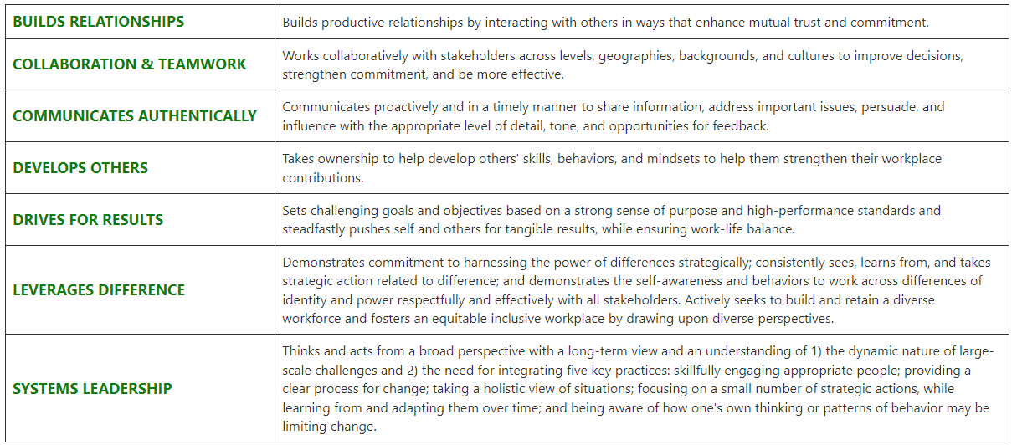

The Nature Conservancy is an Equal Opportunity Employer. Our commitment to diversity includes the recognition that our conservation mission is best advanced by the leadership and contributions of people of diverse backgrounds, beliefs, and cultures. Recruiting and mentoring staff to create an inclusive organization that reflects our global character is a priority and we encourage applicants from all cultures, races, colors, religions, sexes, national or regional origins, ages, disability status, sexual orientations, gender identities, military, protected veteran status or other status protected by law.
TNC is committed to offering accommodations for qualified individuals with disabilities and disabled veterans in our job application process. If you need assistance or an accommodation due to a disability, please send a note to applyhelp@tnc.org with Request for Accommodation in the subject line.

For Internal Reporting:
Job Title: Conservation Practitioner V
Job Family: Conservation
Internal Job Code: 450004

TO APPLY:
Please visit www.nature/org/careers and search for job #54129.
Please upload a resume and cover letter.

