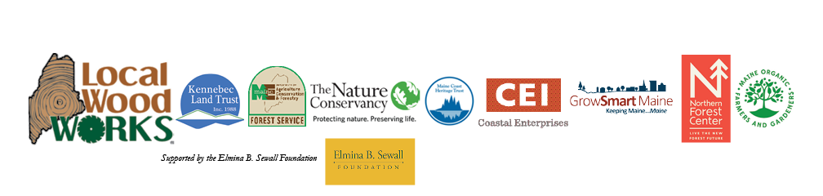

LOCAL WOOD WORKS SEEKS PROJECT MANAGER
March 1, 2024

Local Wood WORKS is a Maine based partnership overseen by eight entities with a shared interest in maintaining the ecological integrity of Maine’s forested landscape, lowering the carbon footprint of the built environment and supporting locally-owned small businesses. Partners include: Kennebec Land Trust, The Nature Conservancy, Maine Forest Service, Maine Organic Farmers and Gardeners Association, Coastal Enterprises, Inc., GrowSmart Maine, Maine Coast Heritage Trust, and the Northern Forest Center. The project is currently funded by the Elmina B. Sewall Foundation.

Local Wood WORKS emerging priorities include building a case for local sourcing of lumber in affordable housing, improving online tools to facilitate local sourcing of a variety of wood products, and seeking collaborative educational opportunities in the retail arena.

We are seeking a skilled communications professional to work at the intersection of sustainable forest management, rural economic development and low-carbon construction. The project manager is a part-time contracted position.

Responsibilities include:

- Organizing tours, talks, and conferences;
- Communicating with LWW Partners;
- Providing referrals to businesses seeking technical assistance;
- Writing periodic articles for regional publications, grant proposals for financial support, and market reports, as needed; and
- Maintaining a robust online presence through website, e-news, and social media.

Qualifications: The ideal candidate has good networking, writing, and communication skills and familiarity with land conservation, forestry, construction, and housing sectors.
Compensation – Reimbursement at a contracted hourly rate of approximately 20 hours per month.
Applications are due by April 1, 2024 – Please send cover letter, two references, and resume to lee@localwoodworks.org
For additional information: https://www.localwoodworks.org/

Local Wood WORKS dedication to diversity is rooted in the belief that our local conservation efforts are strengthened by the varied backgrounds, beliefs, and cultures of individuals. Fostering inclusivity within our Partnership is a priority. We actively seek applicants from diverse cultures, races, colors, religions, genders, national or regional origins, ages, disability statuses, sexual orientations, gender identities, military backgrounds, protected veteran statuses, or other statuses protected by law.

